🏞️ Class 2
🌞 Welcome to Class 2, Milena! 🍃
Good afternoon, Milena,
Welcome to your second English class. This is part of an exciting academic journey, and I’m truly happy to support you along the way.
Your work as a social researcher in public health is not only important, it’s essential. Helping communities better understand and respond to diseases like yellow fever has a real impact in the world. For that reason, being able to communicate your research clearly and confidently in English will open even more doors, both professionally and globally.
In today’s class, we’ll focus on two key areas: listening and speaking, since those are the skills you told me you want to strengthen the most. The activity we’ll do is a listening and comprehension task based on your real context: your recent fieldwork in Mitú. You’ll listen to a short text about your experience and research, and then answer questions to test your understanding.
Why are we doing this? Because listening to real, relevant English and practicing how to respond is one of the fastest ways to improve fluency, pronunciation, and confidence. These types of exercises help train your ear, expand your vocabulary, and give you tools to express your ideas more naturally, especially in professional situations like meetings or presentations.
We’ll also take time to go over the vocabulary, practice key pronunciation points, and reflect on the structure of the language so you can start using it more comfortably.
Let’s make the most of this session. I’m excited to learn together and help you speak about your research with clarity and power.
Today we’re going to focus on your recent trip to Mitú and reflect on your experiences there both personal and professional.
Since one of your goals is to speak more fluently and naturally, this class will be all about using English to describe real situations, feelings, and reflections. This kind of speaking helps build vocabulary and improve fluency with confidence.
We’ll also read and listen to a short text about Mitú and its indigenous communities, and how yellow fever research is connected to that context. Then, we’ll answer some questions to keep practicing listening, vocabulary, and expression.

Conversation Questions – About Your Trip to Mitú
Warm-up – General experience
- How was your trip to Mitú?
- How many days did you stay there?
- What was your first impression of the place?
- How did you feel during the journey?
- Was it difficult to get there?
- What was the most meaningful part of the experience for you?
Reflection – Based on your fieldwork
6. How many indigenous people or families did you meet or work with?
7. What type of interviews or research activities did you do in the field?
8. What challenges did you face while collecting data in Mitú?
9. Did you notice any cultural practices or beliefs related to yellow fever?
10. How is the progress of your research going after this visit?

🎧 Let’s Begin with Our Listening Activity
First, we’re going to listen to the audio without taking any notes. If you like, you can close your eyes, sit comfortably, and simply focus on the sound and rhythm of the speaker. When you feel ready, we’ll press play.
Then, we’ll listen to the audio a second time, but this time I’ll show you the transcript of the text. We’ll go through it together to check how it’s written, how it’s pronounced, and where the natural pauses and intonation happen.
After that, we’ll take a moment to reflect:
- How did you feel listening to the audio the first time?
- Did you notice any difference when reading and listening at the same time?
Finally, we’ll move on to the comprehension questions. This will help you practice expressing your thoughts in English, using your own words, based on the topic you know so well, your research.
Let me know when you’re ready to start.

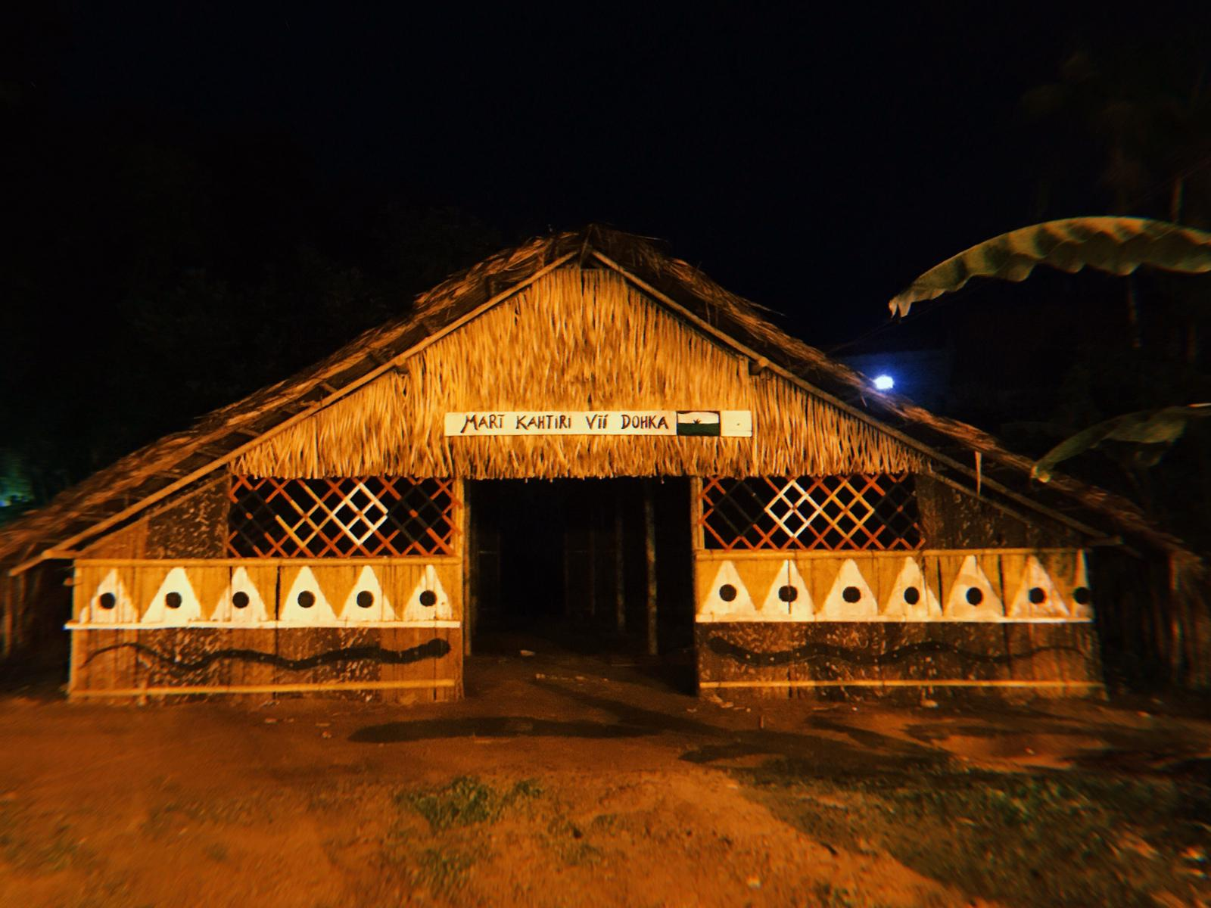

📖 Reading & Listening Activity: Yellow Fever and Indigenous Communities in Mitú

Title: Researching Yellow Fever in Mitú, Vaupés
Mitú is the capital of Vaupés, one of the most remote departments in the Colombian Amazon. It is located deep in the rainforest, surrounded by rivers, jungle, and rich biodiversity. Mitú is not connected to the rest of Colombia by road, the only way to get there is by plane or river transport. This isolation has a direct impact on the local health system, which is often limited in infrastructure, access, and medical resources.
Mitú is home to diverse indigenous communities who have lived in this region for generations. Some of the main ethnic groups include the Cubeo, Tucano, Desano, Wanano, and Tanimuka peoples. These communities maintain their own languages, traditions, and ancestral knowledge systems. Their relationship with nature is deeply spiritual, and their health beliefs often combine traditional medicine with some biomedical practices.
Due to its tropical climate and ecological conditions, Mitú is considered a high-risk zone for mosquito-borne diseases such as yellow fever. Yellow fever is a viral disease transmitted by mosquitoes. Symptoms can include fever, muscle pain, vomiting, and fatigue. In severe cases, it can cause internal bleeding and organ failure. While there is a vaccine, many people in these regions face barriers to access, lack of information, or cultural resistance to vaccination campaigns.
This is where social research becomes critical. In her work, Milena travels to Mitú to study how indigenous communities understand and experience yellow fever. She collects qualitative data through in-depth interviews and focus groups with local families, health workers, and traditional leaders. These conversations explore how people perceive illness, how they access health services, and what obstacles they face when it comes to vaccination and prevention.
Milena’s presence in the community is also an opportunity to build mutual trust and respect. These research trips are not only about gathering data, they are about listening deeply, understanding cultural contexts, and bringing those perspectives into public health strategies. Her work contributes to creating health programs that are more inclusive, respectful, and culturally appropriate for the realities of indigenous populations in Mitú.
Through this kind of social research, we can design more effective responses to diseases like yellow fever, responses that do not ignore the voices of those most affected.

Comprehension Questions – Mitú and Yellow Fever Research
Part 1: Multiple Choice
- Where is Mitú located?
a) In the Andes
b) In the Caribbean coast
c) In the Amazon rainforest
d) In central Colombia
- How can people access Mitú?
a) By road and train
b) By airplane or river
c) By car and bicycle
d) Only by boat
- Which indigenous groups are mentioned in the reading?
a) Wayuu and Kogi
b) Cubeo, Tucano, Desano
c) Inga, Yanacona, Misak
d) Muisca and Embera
- What are some symptoms of yellow fever?
a) Headache and skin rash
b) Fever, muscle pain, vomiting
c) Sore throat and coughing
d) Sneezing and chest pain
- What is one goal of Milena’s research?
a) To test new medicines
b) To teach English to communities
c) To improve cultural understanding in public health
d) To promote tourism in Mitú

Part 2: True or False
- Mitú has strong road connections with the rest of Colombia.
- Some communities in Mitú combine traditional and biomedical health practices.
- Yellow fever can lead to serious health complications.
- Milena uses focus groups and interviews to collect data.
- Her research ignores cultural perspectives and focuses only on data.
Part 3: Open Questions
- Why is Mitú considered a remote area?
- What makes the indigenous communities of Mitú vulnerable to yellow fever?
- What research methods does Milena use during her visits?
- Why is building trust important when doing research in indigenous communities?
- How does Milena’s work help improve public health strategies?

📝 Answer Key
Multiple Choice
- c) In the Amazon rainforest
- b) By airplane or river
- b) Cubeo, Tucano, Desano
- b) Fever, muscle pain, vomiting
- c) To improve cultural understanding in public health
True or False
6. False
7. True
8. True
9. True
10. False
Sample Answers – Open Questions
11. Because it’s only accessible by air or river and has no road connections.
12. Due to limited healthcare access, distance, and cultural resistance to vaccination.
13. She uses qualitative methods like interviews and focus groups.
14. Trust helps communities feel safe and respected, which improves the quality of the data.
15. Her work makes public health efforts more inclusive and relevant to the local culture.

💚 Feedback presentation, class 2
Milena, overall your explanation is clear and you communicate the main ideas of the project well. However, there are some areas where you can improve to sound more natural and confident in English.

First, work on pronunciation of key words like “European Union”, “endemic”, “epidemiological”, “experimental”, and “disseminated”. Pay attention to syllable stress and make sure to pronounce each word fully without dropping sounds at the end.

Second, improve your intonation by emphasizing important concepts and contrasts. Right now, your tone is quite flat, which makes it harder for the listener to follow and stay engaged. Try using rising intonation when you introduce new ideas and falling intonation when you finish a thought. Pausing between major points will also help you sound more fluent and allow your audience to process the information.

Third, focus on grammar and word choice. For example, avoid unnecessary repetition of words like “co-designed” and use more precise expressions such as “delivery of health services” instead of “deliver of health service” or “level of trust” instead of “trustness”.

Finally, consider breaking up your long sentences into shorter ones. This will help you maintain clarity and make your speech sound more structured and professional.

Your content is strong, and with a little more work on delivery, you will be able to present it in a way that is both natural and engaging for an international audience.

MILENA

A little context of research. This is an international project funded by the European Union with the participation of at least 10 institutions. Only my institution, CIDEIM, is Latin American. The other ones are universities and research centers in Europe. The project is 4 years. Inside the big project, there are 5 projects. Each one analyzes different dimensions of yellow fever. For example, the clinical approach, the epidemiological approach, the basic science. In my case, I work in the Work Package 5. There is a social study about yellow fever.

Yes, you can see the prevalence of knowledge and acceptance. And the other part is an experimental study in which communication materials will be co-designed and evaluated and implemented next in the national context. In this task, the experimental will be co-designed, yes? An intervention with communication materials to educate the people will be co-designed and next evaluated if really it was useful to increase the knowledge and acceptance. And next, the same communication plan created will be disseminated in a country context, in Germany and Colombia.

This part is very long, but as a summary, the social study has two big parts. The first one is a diagnostic about perceptions. The second part is to understand how the people form its perception about vaccination and trust about the vaccines. With this objective, first we will conduct a qualitative study using focus groups and interviews to explore the perceptions and understanding what factors define these perceptions and trustness and all factors that involve this perception. Next, we will apply a national survey to explore with more representative data the acceptance and knowledge on the information and media that the people use to take the decision if access to vaccines or not. This is the first big part.

CORRECTED

A little context about the research: This is an international project funded by the European Union with the participation of at least 10 institutions. Only my institution, CIDEIM, is based in Latin America, while the others are universities and research centers in Europe. The project will last four years. Within this large project, there are five sub-projects, each analyzing different dimensions of yellow fever. For example, one focuses on clinical aspects, another on epidemiology, and another on basic science. In my case, I am part of Work Package 5, which involves a social study on yellow fever.

In this study, we examine the prevalence of knowledge and acceptance regarding yellow fever vaccination. Another important component is an experimental study in which communication materials will be co-designed, evaluated, and later implemented at the national level. In this task, the intervention using these communication materials will first be co-designed to educate people, then evaluated to determine if it effectively increases knowledge and acceptance. Finally, the communication plan developed will be disseminated in both Germany and Colombia.

To summarize, the social study has two main parts. The first part is a diagnostic study to explore people’s perceptions. The second part aims to understand how people form their perceptions about vaccination and their trust in vaccines. To achieve this, we will begin with a qualitative study using focus groups and interviews to explore perceptions and identify the factors that shape trust and decision-making. Next, we will conduct a national survey to gather more representative data on vaccine acceptance, knowledge, and the types of information and media people use when deciding whether or not to get vaccinated. This is the first major component of the study.

QUESTION

Milena, is this the first time you’ve read a transcript of yourself speaking in English? How do you feel about seeing your ideas written out like this?

One thing we noticed is that there are some filler words and repetitions (like “yes?”, “and next”, “co-designed”) that make your speech sound less fluent. This is very common when speaking in a second language, and it happens because we are thinking and speaking at the same time.

To improve this, here are some tips:

• Take short pauses instead of using fillers. A small pause can actually make you sound more confident and professional.

• Practice using linking words like “so”, “therefore”, “in addition”, or “finally” to connect ideas smoothly.

• Record yourself speaking and listen for repeated phrases. Replace them with synonyms or a pause.

